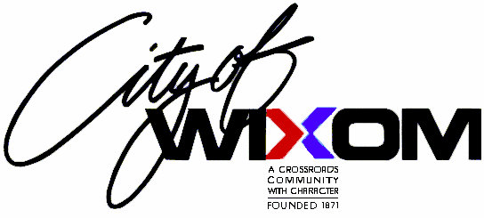

Adopt-A-Park Program Application

Name ________________________________________________________

Organization:___________________________________________________

Address ______________________________________________________

City ______________________________________
State ________________
Zip Code _____________

Day Phone ____________________________________

Evening Phone _________________________________

Cell Phone_____________________________________

Preferred Park Location:

First Choice: __________________________________________________

Second Choice: ________________________________________________

Name to appear on Adopt-A-Park sign: ______________________________

_____________________________________________________________

In consideration of participating in the Wixom Adopt-A-Park Program, the above named individual hereby agrees to abide by and conform to all of the program operational points, safety guidelines as well as all state and local regulations pertaining to pedestrian activities within the road right-of-way.

Signature Date

_________________________________ _______________

