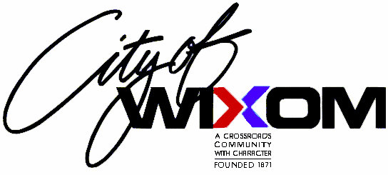
City of Wixom Adopt-A-Road Program

Thank you for your interest in the City of Wixom’s Adopt-A-Road Program. By participating in this program, you will be part of a large community based volunteer group that contributes to the success and sustainability of our City. Any civic minded group, business, industry or individual is welcome to participate. The goals for the Wixom Adopt-A-Road Program are:

- To save taxpayer dollars by providing assistance to the cleaning of the City’s streets and roadways.
- To raise public awareness of the cost of littering.
- To promote civic responsibility, pride and volunteerism.
- To improve the environment.

The Wixom Adopt-A-Road Program is administered and supported by the Department of Public Works. To effectively and efficiently administer the program, the DPW has developed the following points of operation.

- The adopting organization/group will commit to a minimum one-year period of adoption. During this period, the organization/group will remove litter and debris from a selected section of street or roadway a minimum of three (3) times per year; spring, mid-summer and fall.

- The Department of Public Works will provide the adopting organization/group with the following:
  - Necessary quantity of trash bags.
  - Reflective safety vests for all participants.
  - A general safety brochure.
  - Collection of full trash bags the next regularly scheduled DPW workday.
  - An organization/group recognition sign at the limits of the street or roadway segment.

- The adopting organization/group and specifically its signatory representative will be responsible for securing reflective safety vests from the DPW, distributing them to participants, enforcing their use and for returning them, along with any unused trash bags to the DPW.

- Group participants shall hold a safety briefing prior to any pick-up, conducted by the adopting organization/group with City supplied literature.

- Group participants must be at least twelve (12) years of age. Those participants between the years of twelve (12) and sixteen (16) shall be accompanied by a parent or guardian.

The following pages include an Adopt-A-Road application, safety briefing brochure and a sign-in sheet. For additional information on the City of Wixom Adopt-A-Road Program, please call the Department of Public Works at (248) 624-0141.

Sincerely,

Tim Sikma
Director of Public Works

