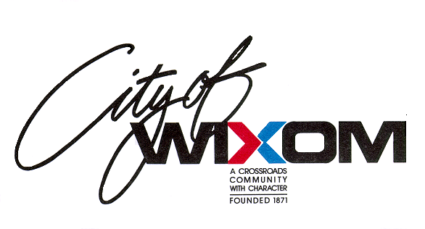 **CITY OF WIXOM**

### PUBLIC HEARING NOTICE

The Wixom Zoning Board of Appeals will conduct the following public hearing at the regular meeting scheduled for Monday, March 14, 2022, for the following topic:

**PUBLIC HEARING FOR VARIANCE # PZBA22-003**: **49178 ALPHA COURT, WIXOM, MI, 48393**: The applicant is seeking a variance from *Section 18.13.080Accessory Uses and Structures, Wind Generators,* to construct five (5) helical turbines in the front yard. Ordinance standards require that wind generators be located in the rear and side yards only. The Wixom Municipal Code requires approval of a dimensional variance from the Zoning Board of Appeals when it can be shown that ordinance standards have not been met. The property is zoned IRO, Industrial Research Office, where the use is permitted in the district. The parcel number is 22-08-326-045.

The Zoning Board of Appeals meeting will begin at 7:30 p.m.

Persons having any questions regarding these matters are urged to attend this meeting or contact Construction & Development Services at (248) 624-0880.

Publication: February 23, 2022 Catherine Buck, City Clerk

City of Wixom, (248) 624-4557